Chapter 2: Methods
2.1 Experimental Animals
All experiments were performed using young female (postnatal day (P) 27 to 39) Sprague Dawley rats (RRID:MGI:5651135) obtained from Charles River Laboratories (Quebec, Canada). Rats arrived at P22-24 and were housed in groups of 4 in polycarbonate cages. Cages contained wood shaving bedding, paper towel strips, and a wooden block, green nyla bone, and two Crawl BallsTM (Bio-Serv) for enrichment. Animals were provided with standard rat chow and water ad libitum and housed at 21°C and 50% ± 10% humidity on a 12-hour light/12-hour dark cycle that began at 7:30 am. Following arrival, the animals were given at least 6 days to acclimate to these conditions before experiments began. All experimental protocols were approved by the Mount Allison Animal Care Committee (protocol #104140) and in accordance with the Canadian Council on Animal Care guidelines.

2.2 Restraint Stress
Rats were randomly assigned into one of three groups: naive, acute stress, or repeated stress. All animals were weighed prior to the restraint. Animals in the acute stress group were removed from their home cage and underwent a single 30-minute restraint on a bench top in a room different to the holding room. Animals in the repeated stress group underwent five consecutive days of a 30-minute restraint and were housed individually after the first restraint. Restraint was performed at approximately the same time each morning for the five consecutive days, in the same location, and the timing was kept as close as possible across animals (between 7:32 am and 8:56 am). The restraint was performed using Flat-Bottom Rodent Restrainers (Braintree Scientific), with size selection based on animal weight (2 x 5 ” for 30 - 125g; 2.5 x 6 ” for 125 - 250g).

2.3 Brain Removal and Slice Preparation
Between 8:00 am and 10:00 am, immediately following the single (acute) or fifth day of restraint (repeated) for the stress groups, the animal was anesthetized with 5% gaseous isoflurane in oxygen (Dechra Veterinary Products), and approximately 2mL of liquid added to the corner of the chamber. To confirm anesthesia, a toe pinch reflex test was performed. When no reflex was present, the animal was decapitated using a guillotine (World Precision Instruments), and a carotid blood sample was obtained. The brain was quickly removed and immersed in ice-cold slicing solution that contained (in mM): 75 sucrose, 25 glucose, 87 NaCl, 25 NaHCO₃, 2.5 KCl, 0.5 CaCl₂ * 2 H₂O, 7 MgCl₂ * 6 H₂O, 1.25 NaH₂PO₄, saturated with 95% O₂ and 5% CO₂ for a minimum of 20 minutes prior to brain removal.
The brain was then placed on a petri dish, and the anterior, posterior, and dorsal (cortex) regions were cut off. The brain was glued (Krazy Glue) to a vibratome plate with the posterior side down. A small piece of agar was glued on the ventral side of the brain to prevent movement during slicing. The vibratome plate was placed such that the brain was submerged in the ice-cold slicing solution and a line with 95% O₂ and 5% CO₂ was inserted. Coronal slices (250 µm) containing the DMH, identified using a rat atlas (Paxinos & Watson, 2009), were obtained using a vibrating slicer (Leica) and cut into hemi-sections along the midline. Slices were incubated in 32.5°C artificial cerebrospinal fluid (aCSF) that contained (in mM): 10 glucose, 126 NaCl, 26 NaHCO₃, 2.5 KCl, 2.5 CaCl₂ * 2 H₂O, 1.5 MgCl₂ * 6 H₂O, 1.25 NaH₂PO₄, saturated with 95% O₂ and 5% CO₂, for a minimum of 60 minutes, until recording began.

2.4 Electrophysiology
Hypothalamic slices were submerged in a recording chamber and superfused with aCSF. The solution, continuously bubbled with 95% O₂ and 5% CO₂, was delivered at a flow rate of 1 mL/min and kept at 32.5°C using TC-344C Automatic Temperature Controller and Inline Heater (Warner Instruments). The brain slice was kept still using two ~1 cm metal weights placed horizontally on each end and was visualized with an upright microscope (Olympus BX51 WI) and Infinity 2 Camera, live footage of which was projected onto a computer monitor. The DMH was located by using the third ventricle as a landmark.
Whole-cell patch clamp electrophysiological recordings were obtained (Fig. 1) using borosilicate glass microelectrodes with tip resistances ranging from 4.0 to 6.0 MΩ (Model P-1000 Pipette Puller, Sutter Instruments). Two microelectrodes were used for each recording, one for stimulating and one for recording. Neurons were stimulated extracellularly, using a microelectrode filled with aCSF, while the recording electrode in a neuron of interest was filled with an internal solution that contained (in mM): 108 KGluconate, 8 KCl, 8 NaGluconate, 10 HEPES, 2 MgCl₂, 1 K₂EGTA, 4 K₂ATP, 0.3 Na₃GTP, corrected to pH 7.2 with KOH, and between 285-300 mOsm with sterile water. The recording microelectrode was connected to a positive pressure line, and ~1.5 mLs of positive pressure was applied before the recording microelectrode was submerged in the bath. When a DMH neuron of interest was located, the recording microelectrode was gently pushed towards the neuron until a dimple was formed in the cell membrane, then the positive pressure was released and the neuron sealed around the electrode. When the seal reached the giga-ohm range, the neuron was held at -70mV in voltage-clamp mode, and suction was used to break into the cell. If the initial access (Ra) to the cell was between 1 and 2.5 MΩ, the recording proceeded. To measure excitatory currents, picrotoxin (50 µM), a GABA_{A} antagonist, was included in all treatment solutions. Picrotoxin blocked inhibitory GABAergic currents, allowing for only excitatory, glutamatergic currents to be recorded.

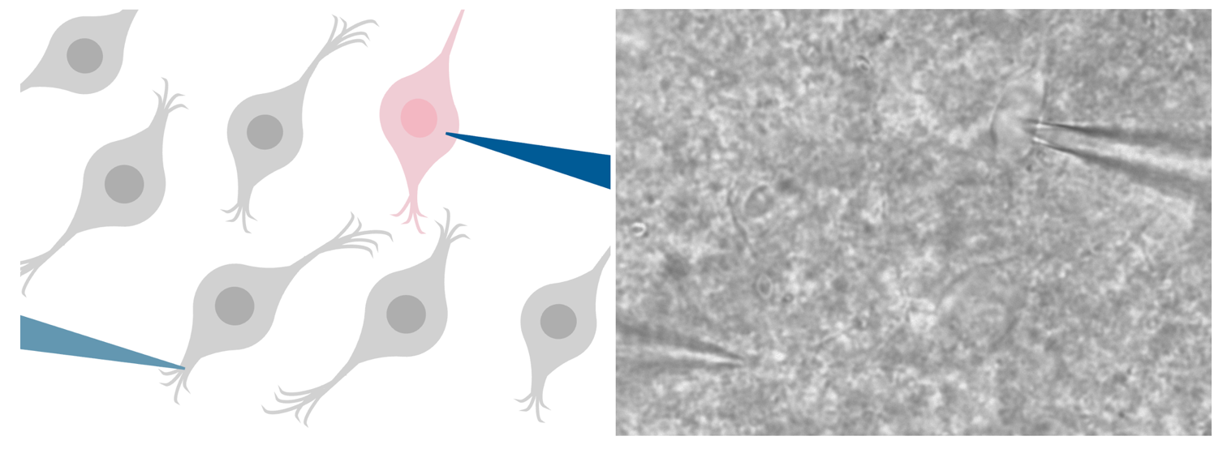
Figure 1: Patch-clamp recording configuration of live neuron recording. On the left, a schematic showing the stimulating microelectrode (light blue) stimulating DMH neurons (gray) in the surrounding tissue to release neurotransmitter, while the recording microelectrode (dark blue) records from the target DMH neuron (pink). On the right, a differential interference contrast image visualized at 40X magnification.

Electrophysiological signals were amplified using the Multiclamp700B amplifier (Molecular Devices) filtered at 1 kHz, digitized at 10 kHz using the Digidata 1550B system (Molecular Devices), and pCLAMP acquisition software (Version 11, Molecular Devices).

2.5 Electrophysiological Measurements
To determine the effects of acute and repeated stress on glutamate transmission in the DMH, the following parameters were measured: evoked current amplitude, paired-pulse ratio, action potential frequency and amplitude.
2.5.1 Evoked Currents
In voltage-clamp mode, cells were held at -70mV. Evoked excitatory postsynaptic currents (eEPSCs) were evoked by a stimulating microelectrode, at a frequency of 0.2 Hz, twice, 50 milliseconds apart, every 5 seconds for the duration of the recording. The first current is classified as eEPSCs, as they are artificially stimulated (evoked) and the result of the release of the excitatory neurotransmitter, glutamate, onto postsynaptic cells, which was measured.
2.5.2 Paired Pulse Ratio
The paired stimulation results in two currents, with the first being eEPSCs. The paired-pulse ratio (PPR), calculated as the amplitude of the second peak divided by the first peak, was used to determine presynaptic release probability. The PPR is inversely proportional to the probability of presynaptic release (Glasgow et al., 2019).
2.5.3 Coefficient of Variation
The coefficient of variation (CV) is calculated by dividing the standard deviation of the data by the mean, and the 1/ CV² is the result of squaring and taking the inverse of that result. 1/ CV² gives additional insight into mechanisms that may be driving changes in presynaptic release (Van Huijstee and Kessels, 2020).
2.5.4 High Frequency Stimualtion
The eEPSCs were recorded for a 5-minute baseline period, then to study activity-dependent plasticity in the DMH, high-frequency stimulation (HFS) was applied at 100 Hz for 4 seconds, repeated twice, 20 seconds apart (Crosby et al., 2011). This protocol has been previously used to determine the effect of stress on long-lasting changes at GABA synapses (Crosby et al., 2011). After HFS, eEPSCs were recorded for 25 minutes, for a total of 30 minutes. In a subset of experiments, some recordings were also obtained in the presence of an endocannabinoid-CB1 receptor blocker (1-(2,4-Dichlorophenyl)-5-(4-iodophenyl)-4-methyl-N-(1-piperidyl)pyrazole-3-carboxamide; AM251; 5 µM).
2.5.5 Action Potentials
Action potential data was collected immediately with each new cell as a baseline, and again after 25 minutes of eEPSCs after HFS (see 2.5.1 Evoked Currents & Paired Pulse Ratio). In current-clamp mode the resting membrane potential (V_{m}) was noted, and a current injection was applied until the V_{m} reached -70mV, and this current was noted. While holding at -70mV, a current-clamp steps protocol was utilized to assess action potential firing at a series of hyperpolarizing and depolarizing steps. The current clamp steps protocol stimulates the cell for 500 milliseconds with current injections that increase in magnitude from -50 pA to 40 pA, with 250 milliseconds between each step.
The lowest current injection needed to elicit an action potential was used for action potential parameter analysis, and the first action potential of that current injection is used for threshold determination. Using the first derivative method (Farries et al., 2010), peak amplitude, time to peak amplitude, anti-peak amplitude, time to anti-peak amplitude, and half width action potential parameters were determined, relative to threshold.
Action potential frequency (Hz) per current injection was determined by counting the number of action potentials at each current injection.
2.5.6 Membrane Properties
Using the membrane test, after each 5-minute interval the capacitance (C_{m}), membrane resistance (R_{m}), cell access (R_{a}), membrane time constant (Tau), and holding current (I_{hold}) were recorded.

2.6 Statistical and Data Analysis & Software
Data was analyzed using Clampfit (Version 11, Molecular Devices). Statistical analysis was performed using R Statistical Software (Version 4.5.2) in RStudio (Version 2026.01.0+392). Graphs were made using the theme from the package patchclampplotteR (Laureijs, 2025). Data was considered significantly different if the p-value was less than 0.05, unless otherwise stated.
Repeated measures analyses were conducted using a linear mixed effects model with an autoregressive correlation structure, as assumptions of sphericity were not met. Log transformation allowed for assumptions of normality and homoscedasticity to be met. This model used the within-subject factor of time interval and between-subject factor of treatment group. The subject was neuron, a random factor. Subsequently, post hoc contrasts were performed to compare the time intervals to the baseline period, where relevant. Paired pulse ratio (PPR), and the inverse square of the coefficient of variation (1/CV²) were calculated using patchclampplotteR (Laureijs, 2025).

